Week 4: Order Management System
Submission Package

1. Orders and Order_Details Table Design
Attribute | Description | Constraint
Order_ID | Unique order identifier | Primary Key
Customer_ID | Customer reference | Foreign Key, NOT NULL
Order_Date | Date of order placement | NOT NULL
Total_Amount | Total bill amount | NOT NULL, CHECK >= 0
Order_Status | Pending / Shipped / Delivered | NOT NULL, CHECK

Attribute | Description | Constraint
Order_Detail_ID | Unique detail identifier | Primary Key
Order_ID | Order reference | Foreign Key, NOT NULL
Product_ID | Product reference | Foreign Key, NOT NULL
Quantity | Number of products purchased | NOT NULL, CHECK > 0
Price | Product price | NOT NULL, CHECK >= 0

2. Updated ER Diagram
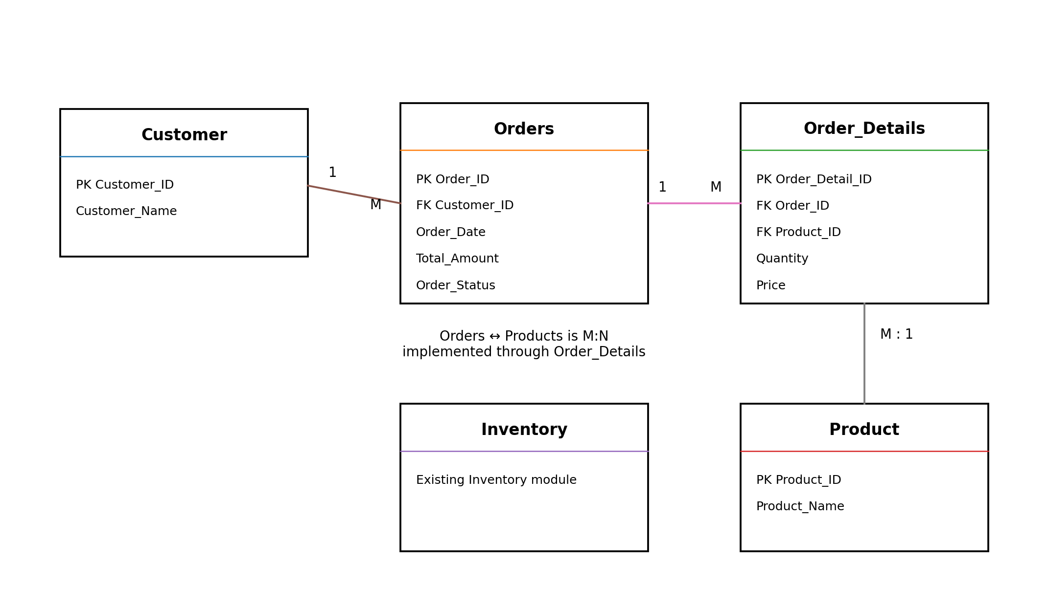
Relationships: Customer (1) to Orders (Many). Orders (Many) to Products (Many), implemented using Order_Details. Inventory is shown as the existing connected module.

3. SQL Table Creation Script
The complete SQL script is provided in the separate file 'Week_4_Order_Management_System.sql'. The core table definitions are:
- CREATE TABLE Orders (...)
- CREATE TABLE Order_Details (...)

4. Order Insertion Queries
The script contains sample insertion queries for orders and their purchased products.
- Order 5001: Customer 101 purchases 1 laptop and 2 mice.
- Order 5002: Customer 102 purchases 1 product.

5. Order Update/Delete Queries
Update examples:
- Change an order status from Pending to Delivered.
- Update a product quantity.
- Recalculate the order total after a quantity change.
Delete examples:
- Delete Order_Details belonging to a cancelled order.
- Delete the cancelled order from Orders.

6. Customer Order History Reports
- Customer Order History — Customer Name, Order ID, Order Date, Total Amount, Status.
- Product-wise Order Report — number of orders containing each product and total quantity sold.
- Customer Purchase Analysis — number of orders, total spending, and average order value for each customer.

Important Schema Assumption
The assignment document gives the Customer and Product relationship requirements but does not provide their complete table definitions. The SQL therefore follows the sample query's names Customer(Customer_ID, Customer_Name) and assumes Product(Product_ID, Product_Name). If your earlier weeks used different column names, replace those names in the foreign keys and reports.

